Sign and Share Club
Registered address:
17 Milton Meadows
Milton, Nr Tenby
Pembrokeshire
SA70 8PL

Telephone: 07971 299449
Email: signandshareclub@yahoo.com

www.signandshare.org.uk

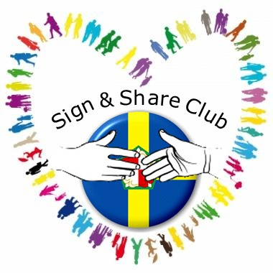

We rely heavily on donations to keep costs down for our members, many of whom are not in employment.

You can support our work by donating online via our website or at BT MyDonate www.mydonate.bt.com Donations by cheques should be sent to the address on this leaflet and made payable to “Sign and Share Club”.

If you are a taxpayer please consider using gift aid so that we recover your tax on the donation. Details of how to do this are on our website or if you wish to receive further information please contact us.

A charity set up in April 2013 to “relieve the needs of deaf people and encourage the use of British Sign Language”.

Whatever your type of deafness (e.g. deaf, profoundly deaf, hard of hearing, deafened or deafblind) Sign and Share Club is for you.

If you are a parent of a deaf child, or are learning British Sign Language and want to meet deaf people, Sign and Share Club is here to support and encourage you. Why not get involved?

All forms of communication are welcomed and supported. Meetings are bilingual – English and sign language

Why come to Sign and Share Club?
We asked our members and they said:

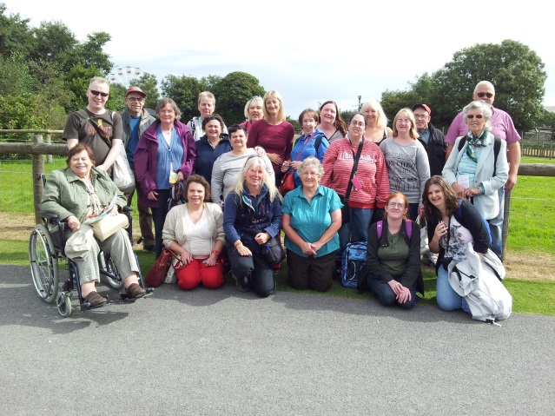
Group photo taken on a trip to Folly Farm

- To meet friends and make new friends
- To reduce boredom and loneliness
- To have fun and enjoy themselves
- To have new experiences
- To learn some sign language
- To practice sign language
- To share information
- To help each other

What do you like about the club?
We asked our members and they said:

- Friendship and company
- Having fun
- Days out
- Everyone is welcome no matter if they sign or don’t sign, are hearing or deaf
- Team work
- We support each other
- We teach each other signs
- Learning signs
- New friends
- We encourage people to be deaf aware

What activities does the club organise?

- Trips e.g. Bowling, local tourist sites, theatre events etc
- Sign and Share FaceBook group
- Designing our marketing materials e.g. logo, website, leaflets
- Team activities and games

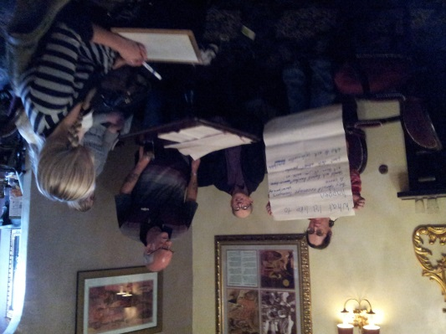
Members discuss the content of this leaflet

- Debates and discussions on interesting topics
- Family Days with activities for all ages
- Talks by professionals on topics of interest
- Training on topics chosen by members e.g. assertiveness

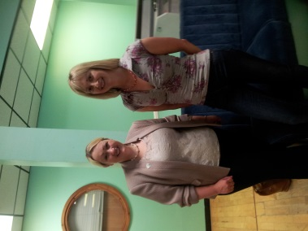
Rebecca Evans AM at our bowling trip with
Shirley David our volunteer Co-ordinator

Where and when do we meet?

Meetings are held on the first Friday of every month but the venue changes depending on the activity. Check our website for details or contact us using the details overleaf.

Who can join Sign and Share Club?

Membership is open to anyone but there are two types of membership.

Full membership – If you are deaf, or if you are a parent/guardian of a deaf child, you can apply for full membership. This includes involvement in any or all of our activities plus the right to vote.

Associate membership – If you are not deaf, but wish to support the club or are interested in learning about deaf issues and/or British Sign Language, then you can apply for associate membership. This allows involvement in any, or all, of our activities but does not include voting rights

